KKAY -

Functionality
The system calculates Work In Process (WIP) to determine the costs incurred for materials that have not yet been delivered to stock. This calculates the value of the unfinished goods.
In Product Cost by Order the work in process is calculated for the Manufacturing Order. The work in process for manufacturing orders is normally calculated at actual costs. Work in process at actual costs is calculated as the difference between the debits for material withdrawals, internal activity allocations, external activities, and overhead costs (that is, the Actual Costs assigned to the object) and the Actual Credits from goods receipts for delivery to stock.
The work in process can be transferred to Financial Accounting and Profit Center WIP = amount if only partial Goods Receipts has been performed.
WIP = 0 if only complete Goods Receipts has been performed.

Scenario
You want to display WIP after it was calculated.

Requirements
Work In Process was calculated.

Menu Path | Accounting → Controlling → Product Cost Controlling → Cost Object Controlling → Product Cost by Order → Period-End Closing → Single Functions → Work in Process → Individual Processing → KKAY - Display
Transaction Code | KKAY

1. Double click on KKAY - Display.

Display Work in Process: Individual Processing

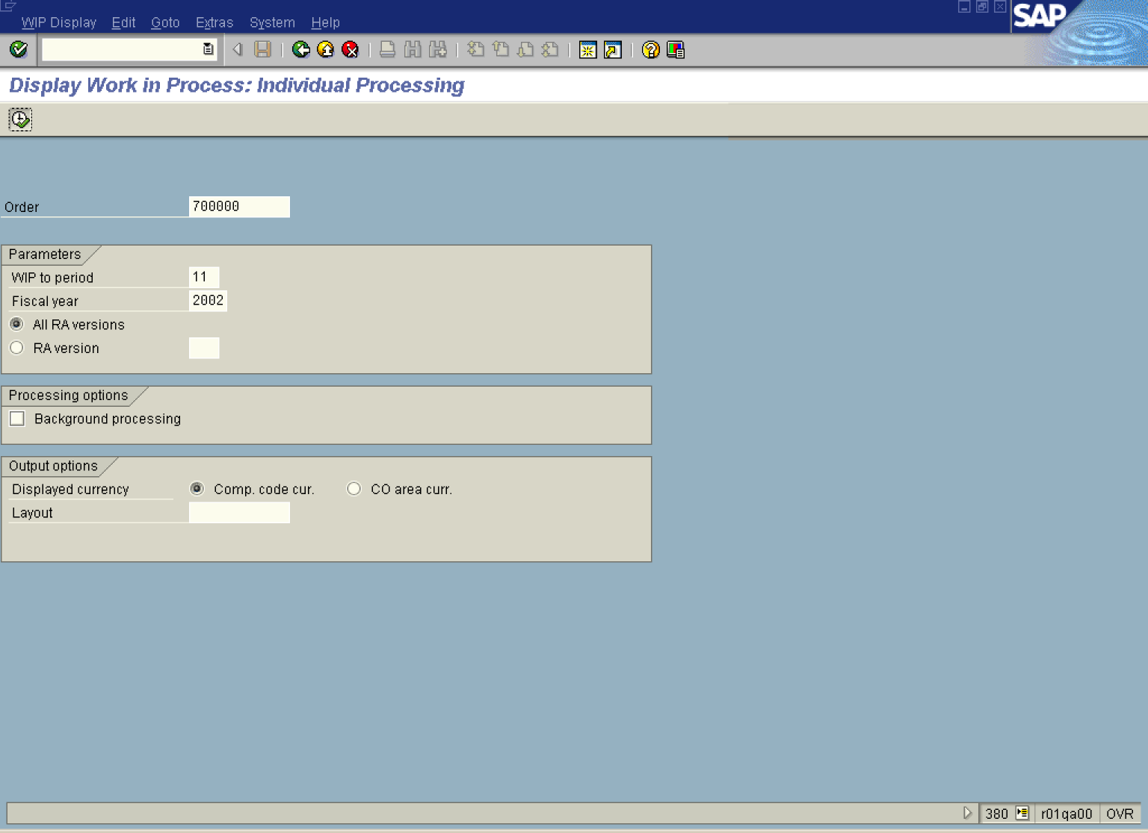

2. Update the following required and optional fields:

Field Name | Field Description | Values
Order | Number identifying the order | Example: 700000
Period | Number identifying a fiscal month. | Example: 11
Fiscal year | Fiscal year for which you calculate variance. | Example: 2002

3. Click the All RA versions radio button.
4. Click the Execute button.

Display Work in Process: Object List

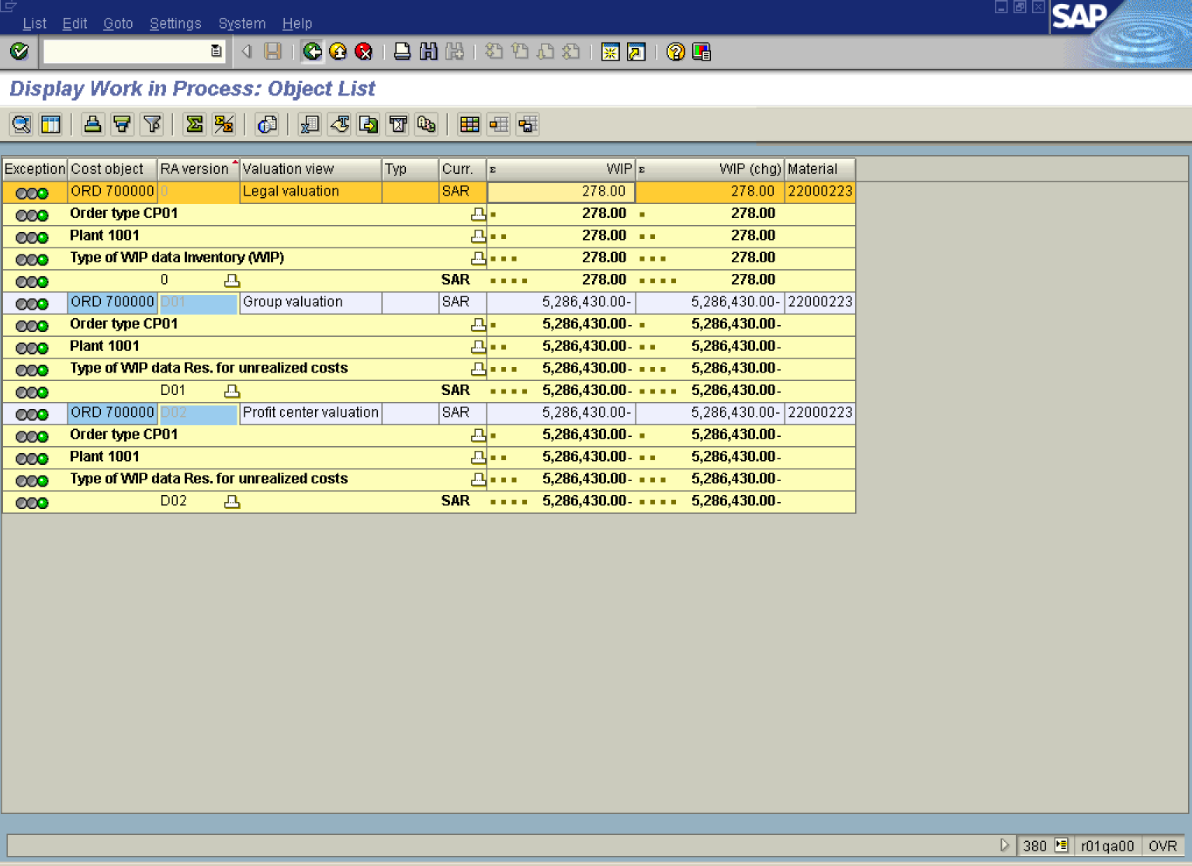

Note: The WIP results are presented per product cost collector per each valuation view, i.e. Legal or Profit Center Valuation View.

5. Click the Back button.

Exit list

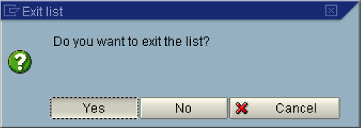

6. Click the Yes button.

Display Work in Process: Individual Processing

7. Click the Back button to go back to SAP Easy Access screen.

